Preview of table locations before normalization:

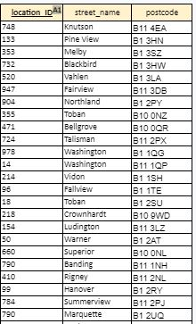

Table is already in 3NF.

PK is location_ID.